[**Hydroponic Greenhouse**](https://green.gmu.edu/campus-sustainability/campus-gardens/presidents-park-greenhouse/) **Automation**

* **Problem:**  The Hydroponic Greenhouse made over $29,000 last year from selling produce to Mason Dining. However, up to 30% of the produce in the greenhouse is lost due to root-rot diseases, over/under-watering and numerous other factors.
  + Currently, irrigation pumps are on timers and may cause over and under-watering as the timers don’t account for changes in temperature, light levels, and humidity.
    - Additionally, the Hydroponic Greenhouse relies upon a significant amount of volunteer labor to complete tasks that could be automated.
* **Desired Outcome:** Reduce disease prevalence and reliance on manual labor to improve crop yield through automation and technological implementation.
  + Develop a detailed operational plan for the implementation of the following:
    - Design a system that allows for live-monitoring as well as the collection of data/information displayed in easy-to-read graphs/spreadsheets so Hydroponic Greenhouse staff can utilize data/information to maximize crop-yield.
      * Examples: dissolved oxygen sensors, existing pH and fertilizer concentration sensors, LED light sensors, CO2 meter, etc.
    - Equipment utilized should allow for remote and live-monitoring and adjustment of all environmental controls as well as crop status via smartphone. For example, the adjustment of water/feed levels, fan operation, turn on/off equipment, etc. Additionally, the system designed should send alerts/notifications when equipment fails, encounters an error, or detects an anomaly. This way, staff will be able to address the issue immediately and mitigate any potential impact to crops.
    - NOTE: there are systems that can be purchased and implemented (such as this [one](https://autogrow.com/our-products-solutions/hydroponics-substrates)) for hydroponic automation. However, we don’t want to purchase a pre-built system, but want one built “in-house.” For various reasons including student/staff/faculty engagement/involvement and fiscal responsibility.
* **Resources:**
  + Suggested Components:
    - Moisture sensing modules/components of soilless root zones that will turn on the pump for irrigation. This will prevent overwatering, which causes fungal and insect diseases. Moisture sensors will be placed in each tomato media bed and each system of horizontal NFT (4 tables/racks) with channels and vertical zip-grow channels, which grow lettuce, herbs and microgreens.
      * Helpful Hack: many boats utilize automated sensors for pumps, monitoring, reporting, etc. These technologies are specifically designed to be used in high-humidity and moisture-rich environments. Pairing maritime technology with Raspberry Pi, Ardurino, and your knowledge/skills might be a great combination!
  + Existing sensors: Each tank has a “fertroller” or fertilizer controller that has pH sensors, fertilizer concentration meters, and water flow sensors. They are made by bluelab and Crop King. They contain wire connections that allow you to receive the data, but it has never been utilized. There are also Wadsworth environmental controllers in each room that turns on and off the heating and cooling systems automatically based on live temperature readings. These devices store a week’s worth of temperature data, that has never been downloaded and saved because the USB drive to do so costs over $600.
  + Greenhouse and Hydroponics layout (Tomato Beds are in the Aquaponics area listed below as well as some of the Microgreen racks) - Ethernet connections are available:

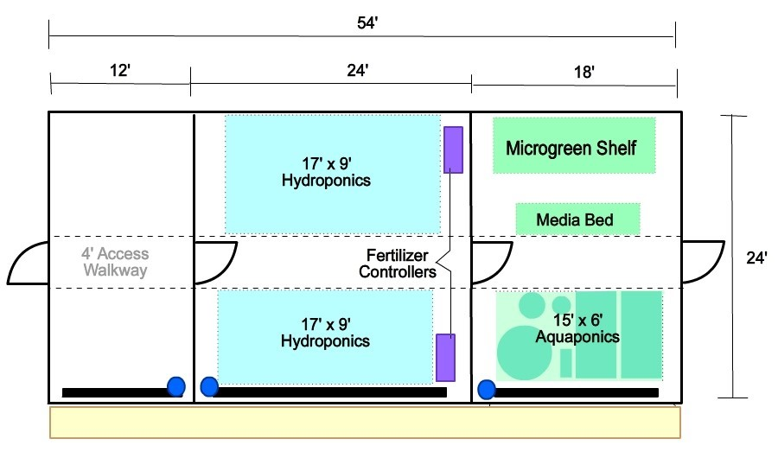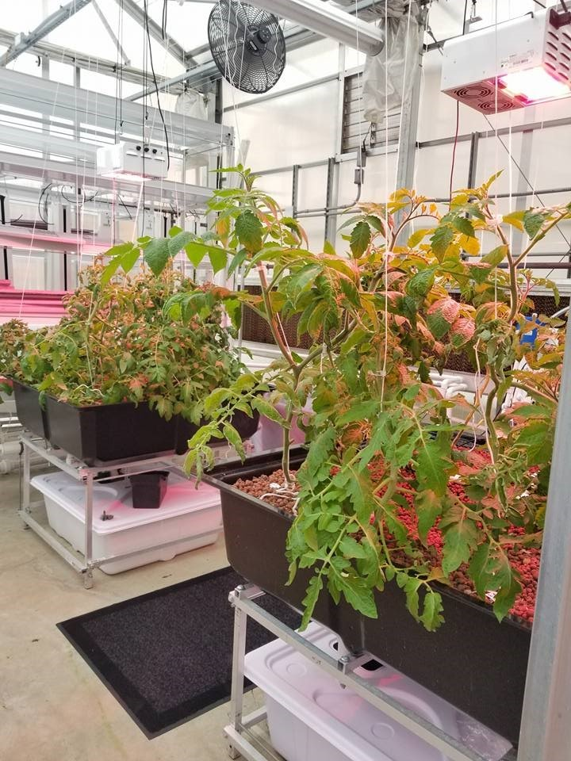

Tomato Media Beds

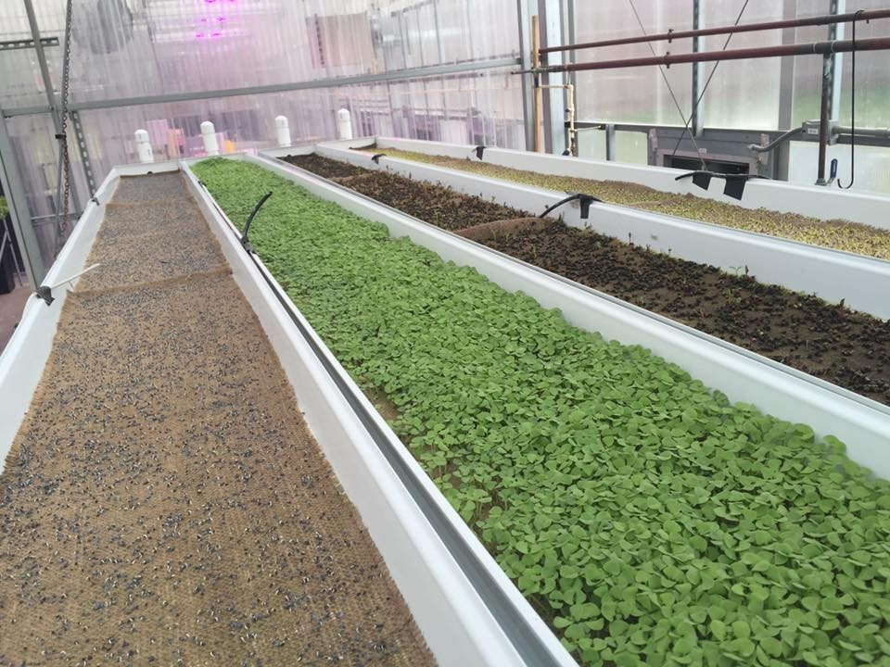

Microgreen rack, top shelf

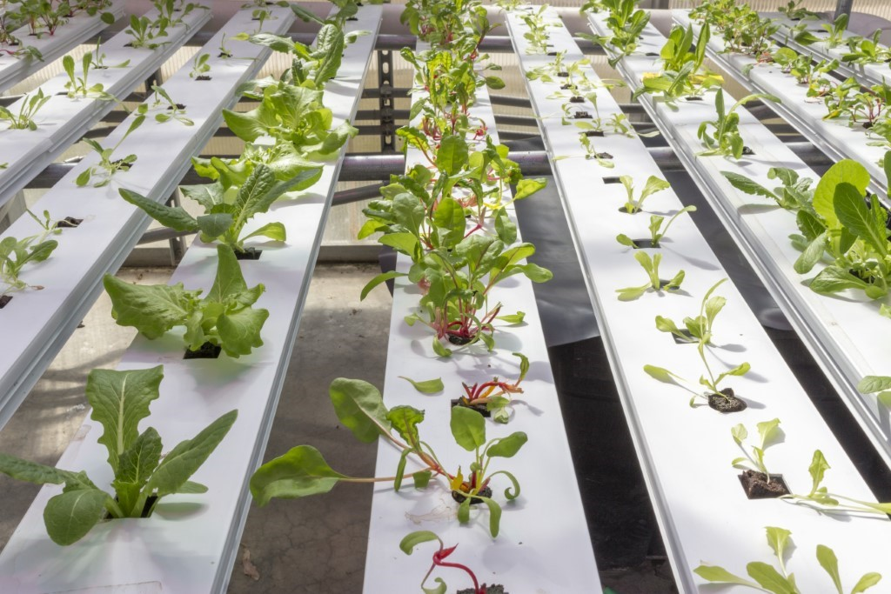

Nutrient Film Technique (NFT) Channels in middle room

* + Light sensors should be used to detect when LED grow-lights are needed or not. Light sensors will ensure that maximum light is provided to increase plant growth without wasting electricity. The light sensors will monitor and report day-length (number of hours of light available for maximum plant growth) in real-time to ensure that LED grow-lights are turned on/off for plants to be exposed to 16 hours of light per-day, which is how much is needed for optimal growth.
  + LED grow lights are in the middle room and over the tomato beds: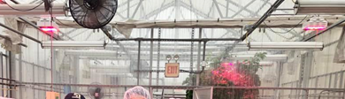

**Carbon Impact and Offset App**

* Problem: A general lack of awareness about the environmental impact an individual’s decisions have as well as limited knowledge about more environmentally-friendly alternatives available at Mason.
* Desired Outcome: A mobile application that allows "self-reporting" of real-time behaviors. Users receive feedback about their decisions as well as Mason-specific alternatives, resources, and information.

Getting started:

* Refer to existing apps for how data is submitted and calculated
* Search for online calculators for quantifying carbon impact
  + Example [here](https://www.nature.org/en-us/get-involved/how-to-help/consider-your-impact/carbon-calculator/) and research [like this](https://www.businessinsider.com/one-hamburger-environment-resources-2015-2) is helpful too.
* [GMU’s Mason Mobile App](http://gettheapp.gmu.edu/)
* Recommendations for green behaviors
  + Turning off lights and keeping thermostat at reasonable settings
  + Monitoring hot water usage and taking short showers
  + Reducing single use items by bringing your own utensils, bottle, and use a reusable bag
  + Reducing Single-Occupancy-Vehicles (SOV) on campus and using public transit (shuttles, Metro, CUE buses)
  + Recycling correctly at bins
  + Eating local and plant-based meals
  + Purchase durable, sustainable, organic, and Fair-Trade goods
  + Volunteer at gardens and greenhouse on-campus
* Incorporate Mason Resources into suggested behavior changes in app and quantify the carbon offset value of using the alternatives as compared to the traditional behavior (ie. A plant-based meal vs a meat-based meal, riding the CUE bus vs. A SOV to campus, etc.)
  + Example resources to use and draw upon for information
    - Shuttle Schedule
    - [Volunteer Opportunities to offset carbon](https://gmufacilities.knack.com/sustainability-volunteer#my-events/)
    - [Sustainability Map](https://www.arcgis.com/apps/webappviewer/index.html?id=09fa43a9873448b18f4fe8a0ba27e75f&extent=-8606742.4347%2C4696970.7468%2C-8604884.0594%2C4698245.0954%2C102100)
      * Water bottle refill stations
    - Coffee punch card
    - [Patriot Bike Share](https://transportation.gmu.edu/bicycle-programs/check-out/)
    - [Composting options](https://green.gmu.edu/campus-sustainability/zero-waste/composting/) in dining halls
    - [Small compost piles: Innovation Food Forest and Potomac Heights Vegetable Garden](https://www.youtube.com/watch?v=UVhW1T8qw3g&feature=youtu.be)
    - [GMU’s Fairfax Campus Information](https://green.gmu.edu/campus-sustainability/)
    - Involvement through [Green Groups (RSO’s)](https://green.gmu.edu/resources/student-groups/)
* Existing apps that are not Mason-specific:
  + [Joulebug](https://joulebug.com/)
  + [13 Green Apps for Environmentalists Who Want to Track Their Carbon Footpring](https://www.bustle.com/articles/91945-13-green-apps-for-environmentalists-who-want-to-track-their-carbon-footprint)
  + [EcoCRED](https://www.ecocred.io/)

**Innovative Sustainable Energy Plan for Fairfax Campus**

* Problem: Mason needs to reduce greenhouse gas emissions to meet our goal of climate neutrality by 2050.
* Desired Outcome: Research and develop an innovative approach to suggest new and unique ways that Mason could reduce emissions on the Fairfax campus.

Background

Since 2007, Mason has committed to the goal of becoming climate neutral by 2050. With the expansion of enrollment at Mason’s campuses and the construction of new buildings, this is becoming an increasingly difficult feat to achieve.

The Innovative Sustainable Energy Plan for Fairfax Campus is an exercise for visualizing innovative options for reducing Mason’s carbon emissions, with the goal of creating a system that offsets [the emissions produced in 2017](https://reporting.secondnature.org/institution/detail!4008##4008). Teams are tasked with researching and suggesting theoretical infrastructure improvements and installations that would allow for the reduction or offset of greenhouse gas emissions. The teams will be judged on how they accurately communicate proposed innovations as well as the impact they would have. A small portion of the evaluation will be how the information is presented, but the areas of primary concern are the proposed ideas, how they intersect with existing campus infrastructure and needs, and if they offset the net amount of emissions produced in 2017 to effectively create an innovative carbon neutrality plan.

Resources:

[George Mason University Fairfax Campus Map](https://info.gmu.edu/wp-content/uploads/FairfaxMap_2019.pdf)

[Sustainable Mason Map](https://green.gmu.edu/campus-sustainability/sustainability-map/)

[Fairfax Campus: Land Records and Maps](https://facilities.gmu.edu/resources/land-development/land-records-and-maps/fairfax/)

[Office of Sustainability: Energy and Buildings Frequently Asked Questions (FAQs)](https://green.gmu.edu/energy-and-buildings-faq/)

**Mason Waste and Energy Dashboard**

* Problem: Mason's energy and waste data is not visually appealing (thanks, Excel) nor readily available for Mason Community members to view in real-time.
* Desired Outcome: A real-time energy and waste dashboard that is easily accessible to all Mason Community members via web or mobile application.
  + The dashboard will be able to display data regarding energy, water usage, and waste on-campus while allowing for specific breakdowns of data by building, per square foot, per floor, per person (per capita), etc.
  + It is desired that the group clearly communicates, along with its dashboard, the necessary hardware/software upgrades and infrastructure that Mason would need to implement to have the dashboard fully implemented and “live.”
* Resources:
  + [Sheridan College Dashboard](http://dashboard.sheridancollege.ca/)
  + [Cornell University Dashboard](https://buildingos.com/s/cornell/storyboard3763/?chapterId=21893)
  + [Iowa State University Dashboard](https://www.fpm.iastate.edu/utilities/energy_dashboard/)
  + [Lucid Technologies](https://lucidconnects.com/)